**PHARMACOGNOSTIC STUDIES OF *Pseuderanthemum carruthersii* (Seem.) Guillaumin (ACANTHACEAE) LEAF**

**Romanus A. Umoha*, Imoh I. Johnnya, Emmanuel R. Idiob, Nsima A. Andya, Goodnews E. Charlesc, Anwanabasi E. Udohd, Imo N. Isobaraa and Otobong M. Umoha**

a Department of Pharmacognosy and Natural Medicine, Faculty of Pharmacy, University of Uyo, Akwa Ibom State, Nigeria.

b Department of Botany and Ecological Studies, Faculty of Science, University of Uyo, Akwa Ibom

State, Nigeria.

d Department of Pharmaceutical and Medicinal Chemistry, Faculty of Pharmacy, University of Uyo, Akwa Ibom State, Nigeria.

c Department of Pharmacology and Toxicology, Faculty of Pharmacy, University of Uyo, Akwa Ibom State, Nigeria.

**Corresponding author: Email: romanusumoh@uniuyo.edu.ng; Phone: +2348028957060 Orcid Id: 0009-0002-0661-6116**

**Abstract**

*Background*: The plant *P. carruthersii* from the family, Acanthaceae is used in the treatment of stomach, lung and liver cancer. This study aims to evaluate the leaves of the plant by employing the quality control parameters.

*Methods*: The fresh leaves of *P. carruthersii* were collected, identified, air-dried, pulverized,and stored in glass bottles. Standard procedures were used to carry out microscopy, micromeritics, chemomicroscopy, fluorescence properties, soluble-extractive values, moisture contents, ash value and GC-MS analysis of the DCM leaf extract.

*Results*: The result showed that the leaf possesses hypostomatic stomata. Under the micromeritic studies, the leaf showed an angle of repose of 35.49o, Carr's Index of 34.83 % and Hausner's ratio of 1.53. Results for the water-soluble, ethanol-soluble, methanol-soluble extractive values were 19.3% w/w,9% w/w and10 %w/w respectively. The result of the fluorescence showed different colours indicating the presence of different phytochemicals. Results for the moisture content, total ash, acid-insoluble and water-soluble ash values were 12.67%w/w, 19.8 %w/w, 1.3 %w/w and 5.8 %w/w respectively. The chemomicroscopy of the leaf powder showed the presence of mucilage, lignin, starch, cellulose and protein. The spectrum of the GC-MS detected a total of nine phytochemicals with five prominent peaks having higher area percentage. The major components that characterized these prominent peaks include; Octadecahydro-benzo [cd] pyrene (25.42%), Cyclopropaneoctanoic acid (11.51%), 1-Phenanthrenecarboxylic acid (11.40%), Ethyl iso-allocholate (11.07%), Cis-11-Hexadecenal (10.48%). The lower peaks comprised of Rhodopin (6.07%), Butyrolactone (7.31%), Acetic acid, hydroxy (7.33%) and 9-Octadecene, 1-methoxy- (E)- (9.37%).

*Conclusion*: The above results stated could be used to establish standards for the authentication of the fresh and powdered drug leaf products of *P. carruthersii.*

**KEY WORDS:** Chemomicroscopy, Hypostomatic, Hausner’s ratio,Micromeriticand*Pseuderanthemum carruthersii*

**INTRODUCTION**

*Pseuderanthemum carruthersii* is a colourful, erect, woody, moderately fast-growing shrub with an attractive crown of waxy, broad, pointed, somewhat irregular, variegated leaves in a combination of different shades of green suffused with purple, silve and regularly produces small clusters of pink flowers. The water extract of the leaves gives a highly viscous product that has been used to heal wounds and inflammations [1]. *Pseuderanthemum carruthersii* var. Atropurpureum (Purple False Eranthemum) and *P. carruthersii* (El Dorado) are the most commonly grown cultivars.

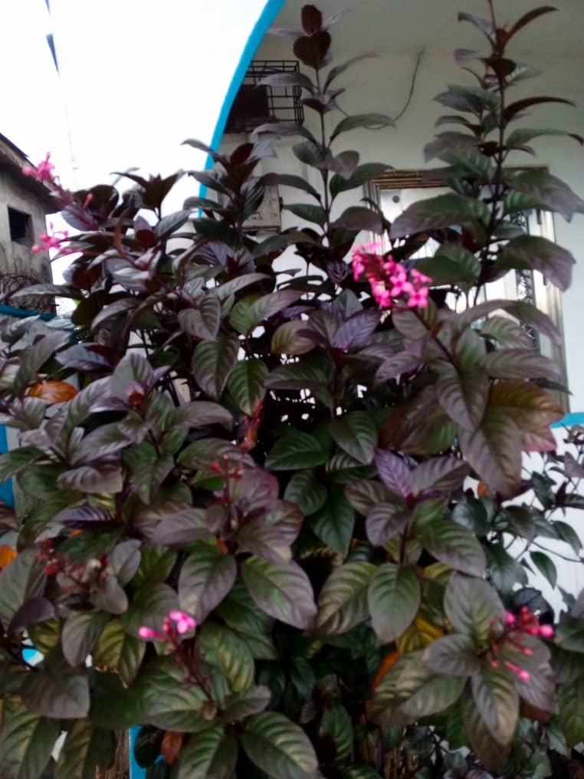

**Figure 1: *Pseuderanthemum carruthersii* in its Natural Habitat**

The research plant, *P. carruthersii* like other species of the Acanthaceae family is found mostly in moist and shady habitats in the West of India and Nepal. They also grown among grasslands in Africa, Brazil, Central America and Malaysia [2].

The leaf extract of this plant was found to contain some fatty compounds, iridoids, phenylethanoids, and flavonoids. The root also composed of lignans and triterpenes. Leaves of *P. carruthersii* have a high content of polysaccharides containing galactose (77.0%), 3-O-methyl galactose (20.0%), and arabinose (3.0%) [1].

*Pseuderanthemum carruthersii* has been discovered to have cytotoxic action on cancer cell and has been used in the past in Vietnam to treat cancers of the stomach, breast, liver and lungs. It also has been found to have inhibitory properties on acetylcholinesterase [3].

**MATERIALS AND METHODS**

**2.1 Materials:**

2.1.1 Biological Materials

The plant *Pseuderanthemum carruthersii*.

2.1.2 Chemical and reagents

The chemicals and reagents used include; distilled water, glycerol, chloral hydrate, sodium hydroxide, 5% concentrated Hydrochloric acid, ferric chloride, concentrated sulphuric acid, dichloromethane, ethylacetate, methanol, ethanol, n-hexane, dragendorff’s reagent, ferric chloride, phloroglucinol, ruthenium red, millon’s reagent, N/50 iodine, sodium hypochloride.

2.1.3 Equipment and Apparatus

Materials used include: beaker, electronic weighing balance, test tubes, filter paper, oven, water bath, pen, pencil, funnel, glass stirrer, measuring cylinders, beakers, conical flash, sieves, spatula, marker, masking tape, foil paper, thongs, evaporating dish, silica gel, knife, mortar and pestle, desiccator, oven, furnace, ashless filter paper, Olympus CX21 electronic microscope, microscope slides, cover-slips, full-scape sheets, meter rule, Amscope MD 500 .

2.2 Methods

2.2.1 Collection and Identification of the Plant Materials

The leaves of the plant were collected from on the 7th of June, 2023 from the Truth and Life Church International, 8 Itam Close Uyo LGA, Akwa Ibom State and was identified by Dr. Johnny, I. I. The plant was then taken to the herbarium and was assigned the Herbarium Number UUPH 1(k).The fresh leaves of the plant were air-dried, pulverized and packed in a well labeled dry container.

**Anatomical Studies**

**Microscopic Evaluation of Leaf**

The standard median portion of the well expanded matured leaf was obtained. Microscopical examinations of the transverse section was made, the Epidermis of both adaxial and abaxial surfaces were also made by placing the leaf on a glass slide. The samples were irrigated with water and scraped gently with a sharp razor blade till loose cells from the epidermis were washed away with water and the desired epidermis was reached. The epidermal peels were further cleared with sodium hypochlorite and rinsed gently with water. The epidermal peels were stained with aqueous solution of safranin-O for (five) 5 minutes and 10% glycerol. The stained samples were mounted on a binocular microscope. Photomicrographs were taken from good preparations using the Olympus CX21 binocular microscope fitted with an MD500 amscope microscope eyepiece camera. Measurements were done at ×10 while ×40 for photomicrographs [5].

**Quantitative Microscopy of the Leaf**

Quantitative microscopy parameters such as leaf constant studies namely stomatal length and width, guard cell length and width, stomatal number, stomatal index, epidermal cell length and width, epidermal cell number, epidermal cell thickness were carried out using standard procedures.

All measurements were made using a calibrated ocular micrometer and 10 microscopic fields chosen at random were used and data presented as mean ± Standard Error of Mean (SEM).

**Stomatal Index Determination**

The stomatal index (S.I) was determined according to Johnny et al [6].

The sample (quantitative microscopy) was placed under the microscope and the stomatal index was determined using the formula;

S.I= $\frac{S}{E+S}$ X100

Where S = Number of stomata per unit area

E = Number of epidermal cells in the same area

**Evaluation of Powders**

**Micromeritic Analysis**

The flow property was determined using standard methods [8, 9]. Which constitutes;

**Bulk Density and Tapped Density**

The weight of 10 g of dried powdered leaf was weighed into 100 ml measuring cylinder and the volume occupied was noted as the bulk volume (Vb). The cylinder was gently tapped repeatedly to obtain a constant volume noted as the tapped volume (Vt). Bulk density was calculated using the formula below;

Bρ = M **/**Vb

Tv = M **/** Tv

Where Bρ = Bulk density

M = Mass of powder

Bv = Bulk volume of powder

Tρ = Tapped density

Tv = Tapped volume

**Hausner’s Ratio and Carr’s index**

Hausner’s ratio a function of interparticle friction was calculated using the formula

Hausner’s ratio = Tp/Bp

While *Carr’s index* = Tp - Bp/Tp × 100

Where; Tp = Tapped density

Bp = Bulk density.

Angle of repose(θ) = Tan**-1** (Heap height of powder **/** Radius of heap base)

**Chemomicroscopic Analysis of Leaf Powder**

Powdered leaf was examined for its chemomicroscopic properties namely mucilage, lignin, starch, oils, calcium carbonate and calcium oxalate crystals using standard procedures [10].

**Fluorescence Analysis of Leaf Powders**

The fluorescent analysis of dried leaf powder was carried out using standard method [11.

**Physico-chemical Evaluation of Leaf Powders**

The physicochemical parameters such as moisture content, ash values (total ash, acid-insoluble ash and water-soluble ash values), soluble extractive values such as ethanol, methanol and water-soluble extractive values were performed according to the official method prescribed by the WHO guidelines on quality control methods for medicinal plant materials [7,12].

**Results**

**Table 1: Microscopic Features of *P. carruthersii* and Standard Error of Mean (SEM)**

|  |  |  |
| --- | --- | --- |
| **Parameters** | **Adaxial surface** | **Abaxial surface** |
| Stomatal type | Absent | Diacytic stomata |
| Stomatal length (µm) | Absent | 14.02(25.352±2.364)42.96 |
| Stomatal width (µm) | Absent | 13.60(20.839±1.214)24.44 |
| Stomatal number (per area view at ×4) | Absent | 30(37.6±2.343)49 |
| Stomatal pore length (µm) | Absent | 9.50(14.573±1.163)20.74 |
| Stomatal pore width (µm) | Absent | 1.90(3.017±0.276)4.75 |
| Stomatal index (%) | 0.00 | 2.5629 |
| Epidermal layer number | 229(298.300±13.171)364 | 241(278.40±6.059)298 |
| Epidermal wall pattern | Straight | Straight |
| Epidermal cell length (µm) | 28.94(39.730±1.652)47.84 | 28.18(43.206±3.818)60.36 |
| Epidermal cell width (µm) | 18.49(21.406±0.661)25.64 | 18.33(22.231±171)36.16 |
| Epidermal wall shape | Polygonal | Polygonal |
| Thickness of epidermis (µm) | 2.02(2.891±0.201)3.78 | 1.73(2.244±0.130)2.85 |

**Values are presented as mean of ten (10) replicates ± SEM**

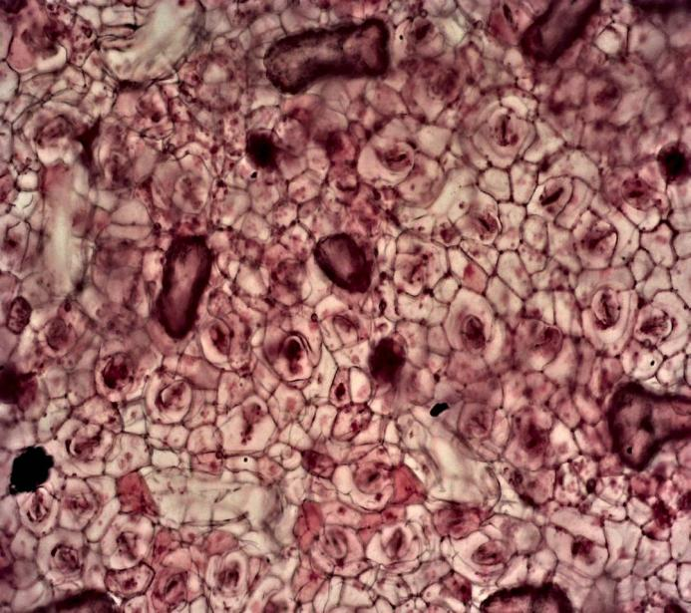

Diacytic Stomata

Tracheid

**Figure 1: Abaxial surface showing microscopic features of fresh leaf of *P. carruthersii* ×10**

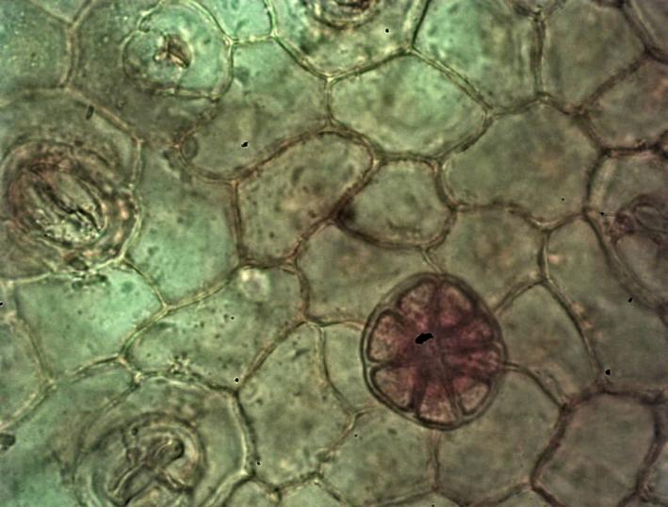

Straight Anticlinal Wall Pattern

Irregular Epidermal Cell

Glandular Trichome

**Figure 2: Abaxial surface showing microscopic features of fresh leaf of *P.******carruthersii***× 40

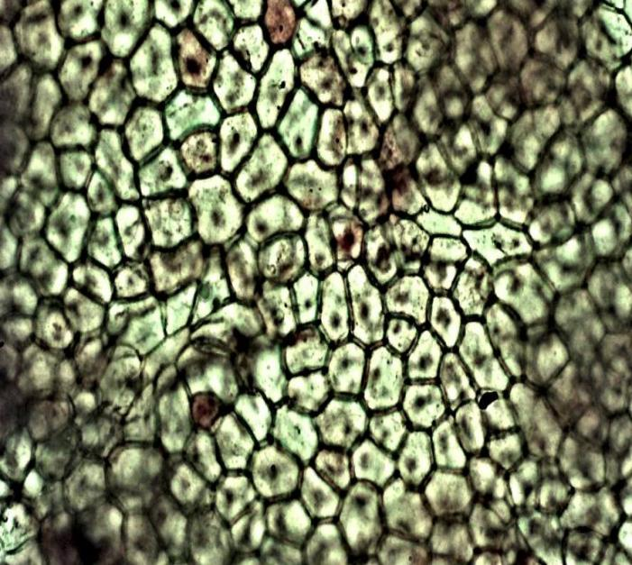

Polygonal Epidermal Cell

Straight Anticlinal Wall Pattern

**Figure 3: Adaxial surface showing microscopic features of fresh leaf of *P. carruthersii* ×10**

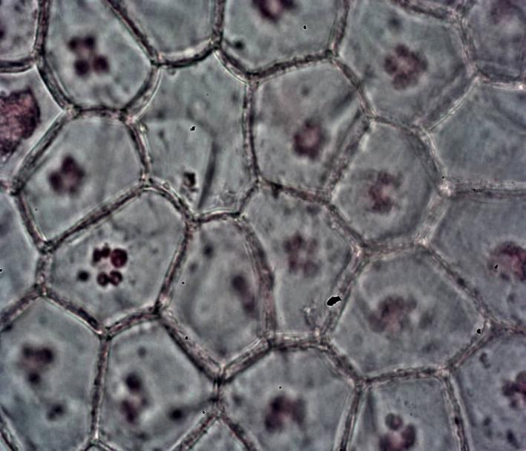

Polygonal Epidermal Cell

Straight Anticlinal Wall Pattern

**Figure 4: Adaxial surface showing microscopic features of fresh leaf of *P. carruthersii* ×10**

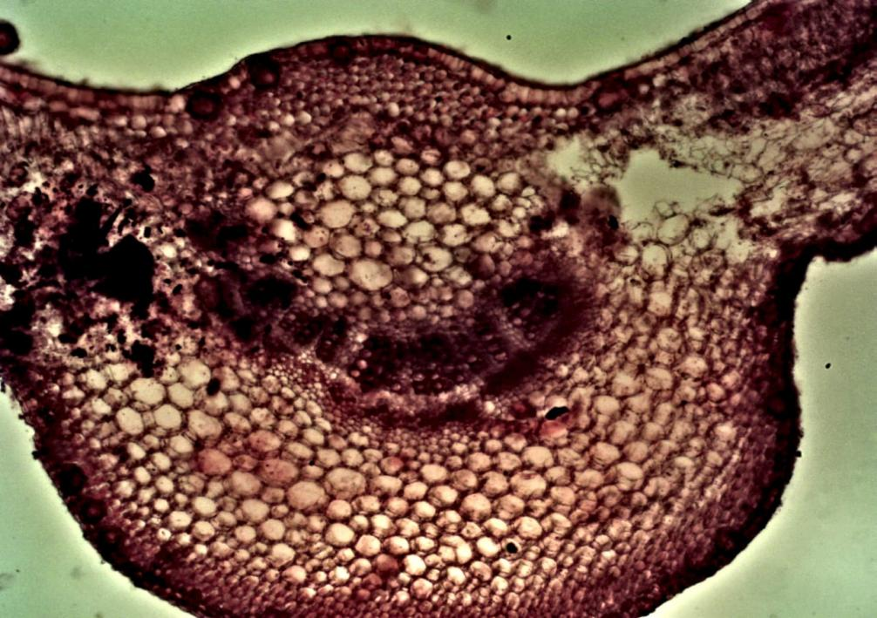

Lower Epidermis

Collenchyma

Parenchyma

Vascular Bundle

Upper Epidermis

**Figure 5: Transverse Section of fresh leaf of *P. carruthersii* × 4**

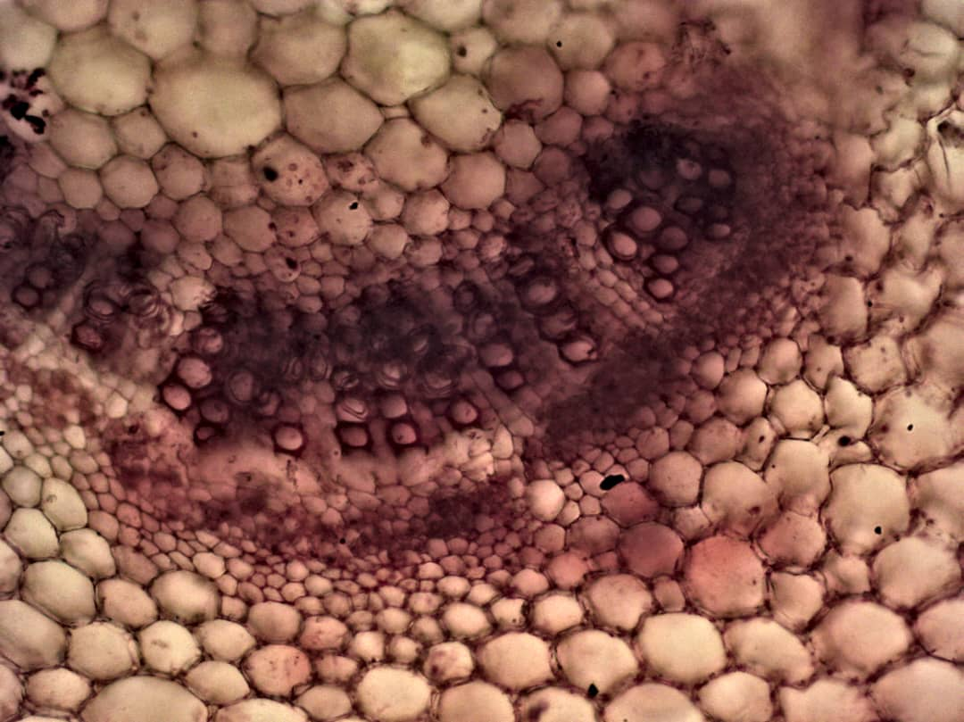

Parenchyma

Phloem

Xylem

**Figure 6: Vascular Bundle of Transverse Section of fresh leaf of *P. carruthersii* ×10**

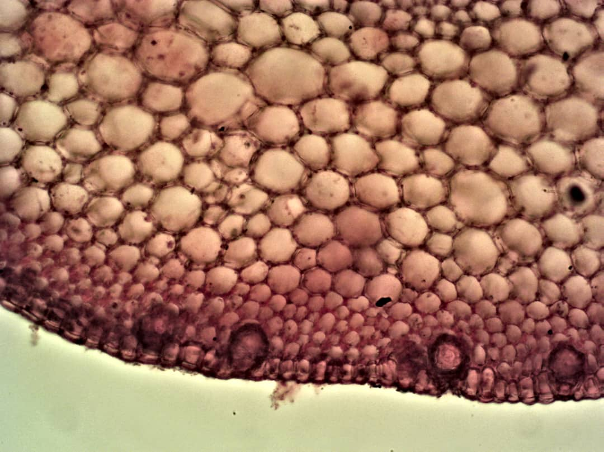

Air Sac

Lower Epidermis

Collenchyma

Parenchyma

**Figure 7: Transverse Section of fresh leaf of *P. carruthersii* × 4**

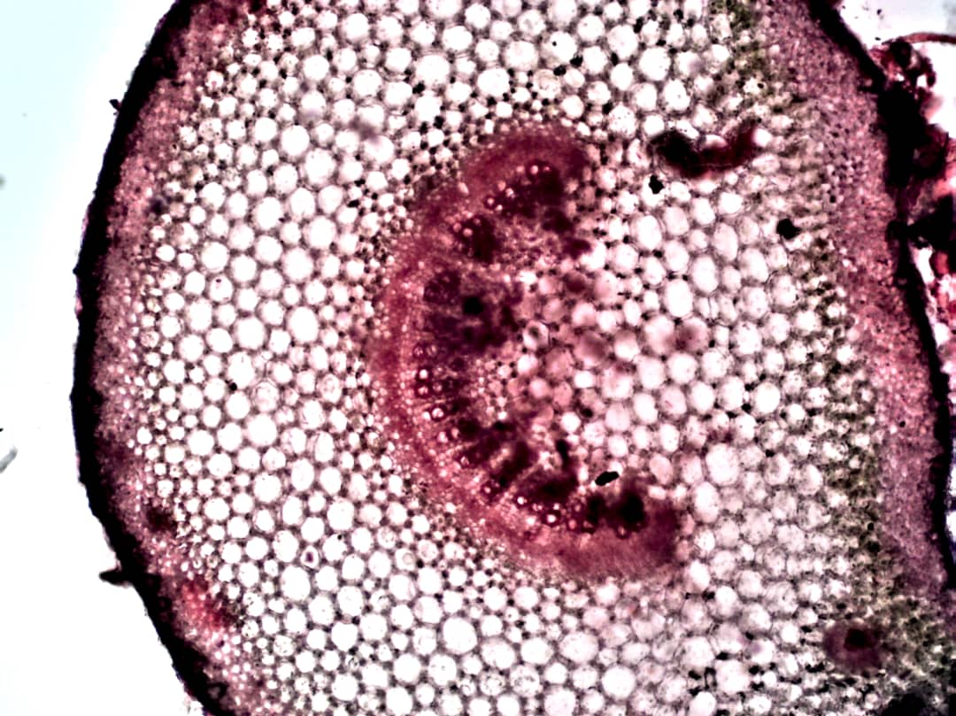

Vascular Bundle

Ground Tissue

Lower Epidermis

**Figure 8: Petiole of fresh leaf of *P. carruthersii* × 4**

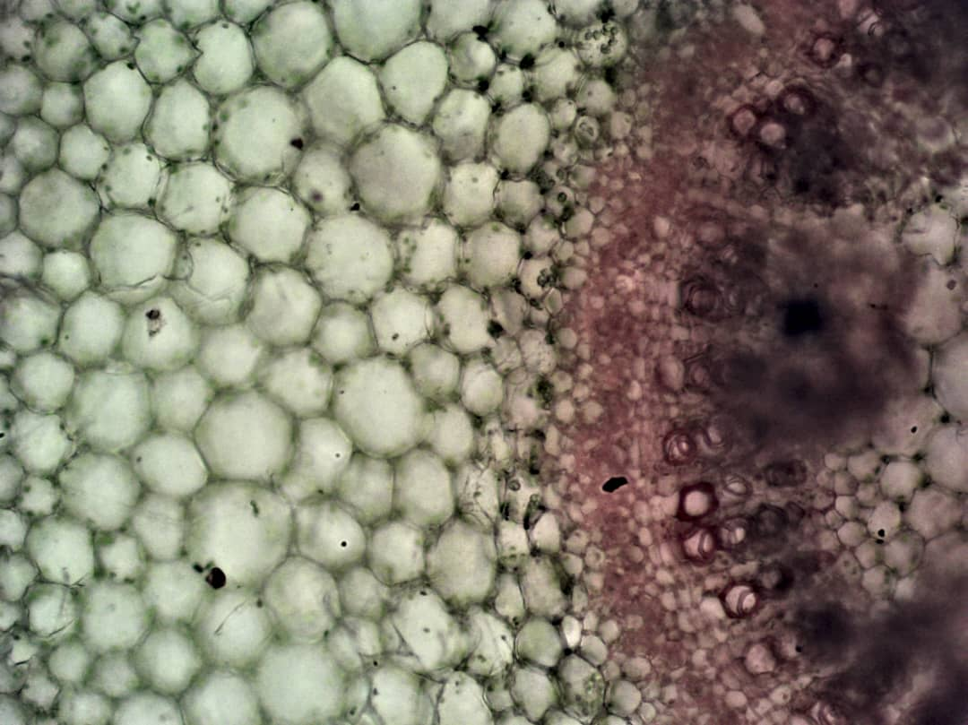

Xylem

Phloem

Parenchyma

**Figure 9: Vascular Bundle of petiole of *P. carruthersii* × 4**

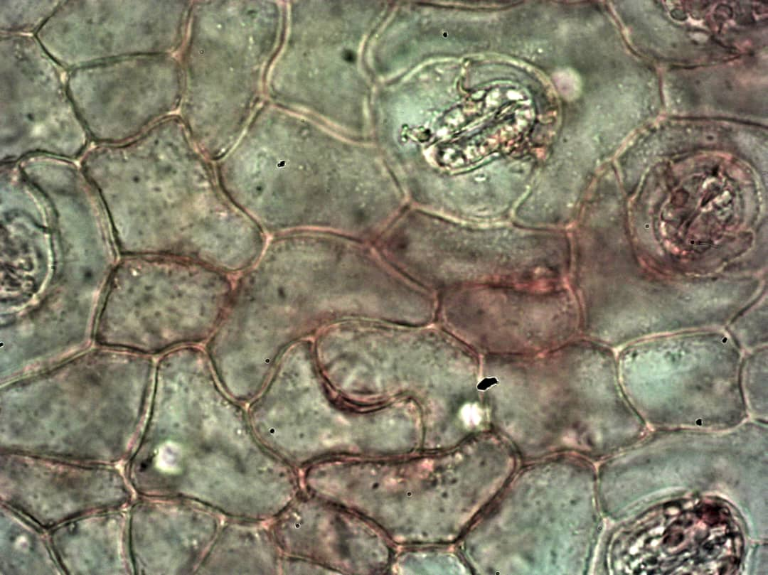

Diacytic Stomata

Irregular Epidermal Cell

**Figure 4.10: Powder Microscopy of fresh leaf of *P. carruthersii***× 10

**Table 2: Micromeritic Properties of *P. carruthersii* Leaf Powder**

|  |  |
| --- | --- |
| **Micromeritic parameters** | **Leaf Powder values** |
| Bulk volume (ml) | 32.33±0.881 |
| Tapped Volume (ml) | 21±0.000 |
| Bulk density (g/ml) | 0.31±0.008 |
| Tapped density (g/ml) | 0.476±0.000 |
| Flow time (s) | 11.17±0.326 |
| Angle of repose (⁰) | 35.49±0.671 |
| Carr's index (%) | 34.83±1.788 |
| Hausner's ratio | 1.53±0.042 |

**Values are represented as mean of three (3) replicates ± SEM**

**Table 3: Chemomicroscopy of *P. carruthersii* Leaf Powder**

|  |  |  |  |
| --- | --- | --- | --- |
| **Constituents** | **Quantitative tests** | **Observation** | **Inference** |
| Mucilage | Ruthenium red, viewed under microscope | Sample stains pink | Mucilage is present |
| Lignin | Phloroglucinol + conc. HCl viewed under microscope | Sample stains red | Lignin is present |
| Starch | N/50 iodine, viewed under microscope | Sample stains blue | Starch is present |
| Cellulose | N/50 iodine + 66% sulphuric acid, viewed under microscope | Sample stains blue | Cellulose is present |
| Proteins | 1% picric acid, viewed under microscope | Sample stains yellow | Protein is present |
| Calcium Oxalate crystals | Sample cleared, viewed under microscope | No crystals | Calcium oxalate crystals is absent |
|  |  |  |  |

**Table 4: Fluorescence Properties of *P. carruthersii* Leaf Powder**

|  |  |  |
| --- | --- | --- |
| **Extract** | **Physical observation**  **Colour** | **UV-365nm**  **Colour** |
| Water | Brown | White with gray boundary |
| Methanol | Light green with deep green boundary | Pink with red boundary |
| Ethanol | Light green with deep green boundary | Pink with red boundary |
| DCM | Yellowish green with deep green boundary | Brownish pink with red boundaries |
| N-Hexane | Yellow | Brownish pink |
| Ethyl acetate | Greenish brown with deep green boundary | Pink |

**Table 5: Water-Soluble Extractive Value, Ethanol-Soluble Extractive Value and Methanol-Soluble Extractive Value for Powdered leaf of *P. carruthersii***

|  |  |  |
| --- | --- | --- |
| **Parameters** | **Weight (g)** | **Percentage by weight (%w/w)** |
| Water-soluble extractive value | 0.19±0.000 | 19.3 |
| Ethanol-soluble extractive value | 0.09±0.000 | 9 |
| Methanol-soluble extractive value | 0.10±0.000 | 10 |

**Values are represented as mean of three (3) replicates ± SEM**

**Table 6: Moisture Content, Total Ash Value, Acid-Insoluble Value and Water-Soluble Value**

|  |  |  |
| --- | --- | --- |
| **Parameters** | **Weight (g)** | **Percentage by weight (%w/w)** |
| Moisture content | 0.2533±0.000 | 12.67 |
| Total ash value | 0.3966±0.000 | 19.80 |
| Acid-insoluble ash value | 0.0267±0.000 | 1.34 |
| Water-soluble ash value | 0.1167±0.000 | 5.80 |

**Values are represented as mean of eight (6) replicates ± SEM for Moisture Content and Total Ash Values. Values are represented as mean of four (3) replicates ± SEM for Acid-Insoluble and Water-Soluble Ash Values**

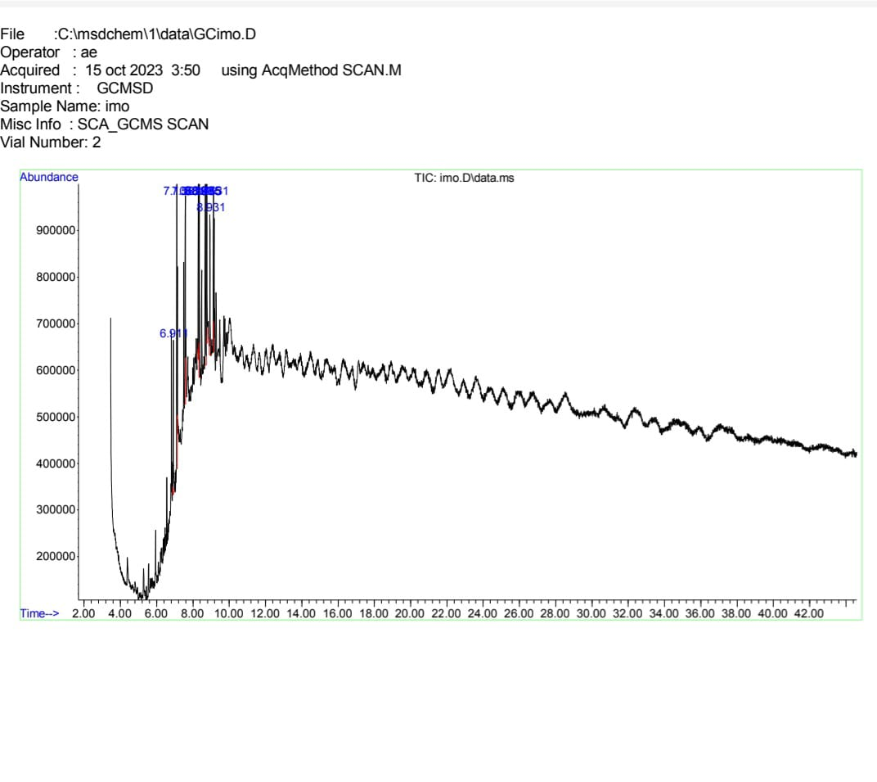

**Figure 12 Showing GC-MS Analysis**

**Table 7: Phytochemical Composition of Dichlorormethane Leaf Extract of *P. carruthersii* by GC-MS Analysis**

|  |  |  |  |  |  |
| --- | --- | --- | --- | --- | --- |
| **S/N** | **Retention time** | **Compound Name** | **Molecular formula** | **Molecular weight** | **Area Percentage (%)** |
| **1** | 6.911 | Rhodopin | C40H58O | 554 | 6.079 |
| **2** | 7.106 | Ethyl iso-allocholate | C26H44O5 | 436 | 11.068 |
| **3** | 7.581 | Cyclopropaneoctanoic acid, 2-[(2-pentylcyclopropyl)methyl]-, methyl ester, trans,trans | C21H38O2 | 322 | 11.514 |
| **4** | 8.296 | 9-Octadecene, 1-methoxy-, (E)- | C19H38O | 282 | 9.377 |
| **5** | 8.347 | cis-11-Hexadecenal | C16H30O | 238 | 10.485 |
| **6** | 8.685 | Octadecahydro-benzo[cd]pyrene | C19H30 | 258 | 25.420 |
| **7** | 8.765 | 1-Phenanthrenecarboxylic acid, 7-ethenyl-1,2,3,4,4a,4b,5,6,7,9,10,10a-dodecahydro-1,4a,7-trimethyl-, ethyl ester, [1R-(1α,4aβ,4bα,7β,10aα)]- | C22H34O2 | 330 | 11.409 |
| **8** | 8.931 | Acetic acid, hydroxyl | C2H4O3 | 76 | 7.332 |
| **9** | 9.131 | Butyrolactone | C4H6O2 | 86 | 7.316 |



Octadecahydro-benzo [cd] pyrene



Cyclopropaneoctanoic, 2-[(2-pentylcyclopropyl)methyl]-



1-Phenanthrenecarboxylic acid, 7-ethenyl-1,2,3,4,4a,4b,5,6,7,9,10,10a-dodecahydro-1,4a,7-trimethyl-, ethyl ester, [1R-(1α,4aβ,4bα,7β,10aα)]-



Ethyl iso-allocholate.

**Discussion**

The pharmacognostic investigations of some physical parameters are helpful in setting standards for a crude drug as these parameters are mostly constant for a plant.

From the experiments carried out, the qualitative microscopic studies of the leaf showed that the leaf is hypostomatic which means possession of stomata only on one surface of the leaf and this revealed that the diacytic stomata on abaxial surface, which is/ was typically surrounded by two or more pairs of subsidiary cells that were positioned at right angles to the guard cells [14]. Table 1 displays a mean stomatal index of 2.5 % for the abaxial surface, mean stomatal length of 25.35 µm, mean stomatal width of 20.83µm, stomatal number of 37.6 on the abaxial surface. The micromeritic studies of the leaf powder of the research plant showed an angle of repose of 35.49 degrees (which indicates a fair flow because it falls within the range of 31-35 degrees; Hausner's ratio of 1.5 indicating a very poor flow as it is within the range of 1.46-1.59 and Carr's index of 34.83 % indicating very poor flow which is between ranges 32%-37 %. Micromeritic properties are the most important parameters to be considered in ensuring the quality of tablets. Micromeritic properties shows the interparticulate resistance between particles of powder which also influence the processing parameters during manufacturing of formulation [15].

Flow properties of a particle may be affected by the particle size, moisture content, particle shape, time of storage, etc. The angle of repose, Hausner's ratio and Carr's index are parameters used in the characterization of flow properties of particles also. An angle of repose is a measure of powder flow. It is used to qualify powder flowability because of its relationship with interparticulate cohesion. Particles flowing at a very large angle of inclination will overcome frictional forces while that which flows at an angle of inclination that is not large will not overcome the frictional forces (adhesion/cohesion). The frictional forces affect the particles flow rate into tableting dies during manufacturing. Hausner's ratio compares the tapped density of a powder to the bulk density.

Powders are in an indirect relationship with interparticulate friction meaning the powders with low interparticulate friction are free-flowing (with ratios less than 1.2) while, powders with high interparticulate friction are less free-flowing (with ratios greater than 1.5). Compressibility index also referred to as Carr's index, compares the bulk density of a powder to the tapped density. It indicates how well powder particles can be compressed into tablet formulations or any other solid dosage form [12]. In alignment with the flow property characterization , the results are said to have very poor flow characteristics.

Chemomicroscopy studies showed the presence of mucilage, cellulose, starch, proteins and, lignin. In soluble-extractive values determination, water had the highest extractive value of 19 %w/w and ethanol and the lowest extractive value of 9 %w/w as seen in Table 5. extractive values play an important role in the evaluation of crude drugs as the specific constituents based on its solubility in a particular solvent used for its extraction can be estimated[16].

The fluorescence property of the powdered leaf sample was conducted for different solvents like n-hexane, dichloromethane, ethyl acetate, ethanol, methanol and, water (according to the

eluotropic series). At daylight and high wavelength (365nm), the extracts spotted on the TLC plate showed different colours as shown in Table 4 which indicates the presence of different phytochemicals. The intensity of fluorescence is used to identify a particular drug and also, differentiate adulterated herbal medicines [17].

The moisture content obtained was 12.66 %w/w which falls within the African Pharmacopoeia, 1986 recommended range of 8-14 %w/w. The moisture content is an indication of the herbal medicines' shelf life. High moisture content indicates that the herbal drug has either been prepared or stored incorrectly. It could lead to enzymatic activation and hydrolytic reactions as well as proliferation of microbial growth which may lead to degradation and loss of active constituents [11].

The total ash values for the powdered leaf as shown in Table 6 is 19.8 %w/w which is above the recommended limit of 14 %w/w according to the European Pharmacopoeia, 2007 [18]. The total ash value measures the degree of purity as well as quality of the crude drug. For a crude drug to be stated a drug of high purity, the ash value should not exceed the limit of 14 %w/w. The acid-insoluble ash value of the powdered leaf was between the stated limit of 2% by the European Pharmacopoeia, 2007 [18]. The value shown in the Table 6 is 1.3 %w/w.

The obtained spectrum of GC-MS analysis of dichloromethane extract of the leaves of *P. carruthersii* is shown in figure 13. The spectrum detected a total of 9 phytochemicals, with some of the prominent peaks having higher retention time than others. Hydroxy acids (HAs) represent a class of compounds which have been widely used in a number of cosmetic and therapeutic formulations in order to achieve a variety of beneficial effects for the skin. Hydroxy acids (αHA) are reported to reduce signs of aging in the skin and are widely used cosmetic ingredients. [19].

Several Butyrolactone containing drugs approved by the FDA are used to treat cardiovascular diseases (spironolactone), xerostomia and eye pressure (pilocarpine) [20]. Other biologically active Butyrolactone are employed for their anti-inflammatory, anticancer, antifungal and antibiotic properties. Butyrolactone, despite serious safety concerns and illegality, people take gamma butyrolactone for improving athletic performance, sleep and sexual performance and pleasure. They also take it for relieving depression and stress, prolonging life, promoting clear thinking, causing relaxation, and releasing growth hormone. GBL is also used to trim fat and as a body- or muscle-builder. Some people take it as a recreational drug [21]. Hexadecanal is used as a food additive, [22]. Hexadecanal is found in human skin, saliva, and feaces. It has a calming effect on mice. Ethyl iso-allocholate from a medicinal rice Karungkavuni inhibits dihydropteroate synthase in *E. coli* [23]*.* Rhodopin is a protein that is essential for vision[24]. Rhodopin, a G-protein coupled receptor in the rod cells of the retina is a biomarker associated with retinal thinning and degeneration [25, 26], suggesting its potential in the early detection and progression monitoring of neurodegenerative diseases.

Plant extracts containing high percentages of 9-Octadecene, 1-methoxy-, (E)- was found to have antibacterialproperties[27].1-Phenanthrenecarboxylicacid,7-ethenyl-1,2,3,4,4a,4b,5,6,7,9,10,10a-dodecahydro-1,4a,7-trimethyl-, ethyl ester, [1R-(1α,4aβ,4bα,7β,10aα)] is used as a non-aqueous viscosity increasing agent [22].

**Conclusion**

This study will help in the possible identification of the plant *Pseuderanthemum carruthersii*

**Conflict of Interest**

Authors have declared that no conflict of interests exist.

**Authors’ contributions**

This work was carried out in collaboration among all authors. RAU and INI designed the study, performed the experimental procedures, statistical analysis, RAU wrote the first draft of the manuscript. Authors RAU and IIJ supervised laboratory experiments. Authors IIJ, ERI, NAA, GEC AEU,INI and OMU, organized data, managed the literature searches, assisted in plant material preparation. All authors read and approved the final manuscript.

**REFERENCES**

1. Vo HB, Berit SP, Le Van T, Andreas K, Tat CT, Christian, WW, Suthajini Y, Thomas H. Neutral Polysaccharide from the Leaves of *Pseuderanthemum carruthersii*: Presence of 3-O-Methyl Galactose and Anti-Inflammatory Activity in LPS-Stimulated RAW 264.7 Cells. Polymers (Basel) 2019: 11(7):12-19
2. Sharma A, Kumar A. Acanthaceae: Taxonomy and uses in traditional medicinal system. *World Journal of Pharmaceutical Research*, 2016, 5(7):403-412.
3. Thi NV, Minh H, Kim PP. Nitrogen-Containing Compounds from *Pseuderanthemum carruthersii* var. Atropurpureum. *Journal of Technical Education Science*, 2018: 33-36.
4. Angiosperm Phylogeny Group. An update of the Angiosperm Phylogeny Group classification for the orders and families of flowering plants: APG IV. *Botanical Journal of the Linnean Society*, 2016: 181(91): 1-20.
5. Killedar GS, Harianth N, Sameer J, Nadaf S, Karade R. Phytochemical potential of*Memecyclon umbellatum*. Burm. Leaf extracts. *Journal of Drug Delivery and Therapeutics*, 2014: 4(2): 30-35.
6. Johnny II, Umoh UF, Umoh R A, Alozie MF, Udobre AS, Igboasoiyi AC, Bassey ME, Andy NA, Udo IJ, Umoh OT. Pharmacognostic Characterization of *Cola* *millenii* K. Schum. (Malvaceae). *Asian Journal of Biology*, 2022: 14(1): 6-24.
7. African pharmacopoeia. General methods of Analysis Pharmacopoeia.,1986: 11:121-208
8. Mbah CC, Builders PF, Akuodor GC, Kunle OO. Pharmaceutical characterization of *Brideliaferruginea*Benth (Euphorbiaceae). *Tropical Journal of Pharmaceutical Research*, 2012: 11(4): 637- 644.
9. Trease GE, Evans WC. Pharmacognosy. Elserviers Ltd., United Kingdom, 2009: 16:560 - 570.
10. Kokate CK, Purohit AP, Gokhale SB. *Analytical Pharmacognosy*, Nirali publication. 2005: 30:199.
11. Khandelwal KR. Practical pharmacognosy techniques and experiments. New Delhi: NiraliPrakashan., 2002: 15 – 163.
12. Kumar D, Gupta J, Kumar S, Arya R, Kumar, T, Gupta G. Pharmacognostic evaluation of *Cayratia trifolia* (Linn.) leaf. *Asian Pacific Journal of Tropical Biomedicine*, 2012: 2(1): 6 – 10.
13. Perveen A, Abid R, Fatima R. Stomatal Types of Some Dicots within Flora of Karachi, Pakistan. *Pakistan Journal of Botany*, 2007: 39(4):1017-1023.
14. Hanif M, Shoaib, MH, Yousuf, RI, Sattar S, Nadeem M, Hussain L, Zia MU, Muhammad IN, Üzair M, Qadir I. Formulation Development of Intermediate Release of Nimesulide Tablets by CCRD for IVIVC Studies. *Pakistan Journal of Pharmaceutical Sciences*, 2014: 27(4):785-792.
15. Romanus AU, Uwemedimo FU, Imoh IJ, Omodot TU, Victor UA, Anwanabasi EU, Akwaowoh AE, Moses AA Etido AM. Phytopharmacognostic Evaluation of the Leaves of *Gnetum africanum* Welw (Gnetaceae). *Journal of Complementary and Alternative Medical Research*, 2020: 11(3): 32-41.
16. Kasthuri OR, Ramesh B. Physiochemical and fluorescence Analysis of Leaves of *Alternanthera brasiliana* (L.) Kuntze and *Alternanthera bettzickiana* (Reege) Voss. *International Journal of Pharmaceutic Science Reviews and Research*, 2018: 51(1):11, 66-71.
17. European Pharmacopoeia. Pharmacopoeial Limits of Crude Drugs. *Strabourg*: *Council of Europe*, 2007: 6: 124-164.
18. Kornhauser A, Wei R, Yamaguchi Y, Coelho SG, Kaidbay K, Barton C, Takahashi K, Beer JZ, Miller SA, Hearing VJ. The Effects of Topically Applied Glycolic Acid and Salicylic Acid on Ultraviolet Radiation-Induced Erythema, DNA Damage and Sunburn Cell Formation in Human Skin. *Compound Newsletter*, 2009: 55(1):10-17.
19. Costa JP, Ferreira PB, De Sousa DP, Jordan J, Freitas RM. Anticonvulsant Effect of Phytol in a Pilocarpine Model in mice.*Neuroscience Letters*, 2012: 523(2):115-118.
20. Hur J, Jan J, Sim JA. Review of the Pharmacological Activities and Recent Synthetic Advances of γ-Butyrolactones. 2021: 22(5):2769.
21. National Center for Biotechnology Information NCBI. PubChem Compound Summary for CID 984, Hexadecanal: <https://pubchem.ncbi.nlm.nih.gov/compound/Hexadecanal>. 2023.
22. National Center for Biotechnology Information. PubChem Compound Summary for CID 49998: <https://pubchem.ncbi.nlm.nih.gov/compound/49998>. 2023.
23. Krishnanunni K, Senthilvel P, Ramaiah S, Anbarasu A. Study of chemical composition and volatile compounds along with in vitro assay of antioxidant activity of two medicinal rice varieties: *Karungkuravai* and *mappilai samba*. 2015: 52: (25)72-84.
24. Sakmar TP, Huber T. Encyclopedia of Neuroscience. *International Journal of Research in Ayuverda and Pharmacy,* 2009: 302-310.
25. Cideciyan AV, Jacobson SG, Beltran WA. Rod function deficit in retained photoreceptors of patients with class B Rhodopsin mutations. 2005: *Sci Rep* 10, 12552.
26. Xiong B, Bellen HJ. Rhodopsin homeostasis and retinal degeneration: lessons from the fly. 2013: 650-660.
27. Karanja LN, K’Owino IO, Wangila PT, Ramkat RC. *Asian Journal of Applied Chemistry Research*. 2021: 9(4):1-16